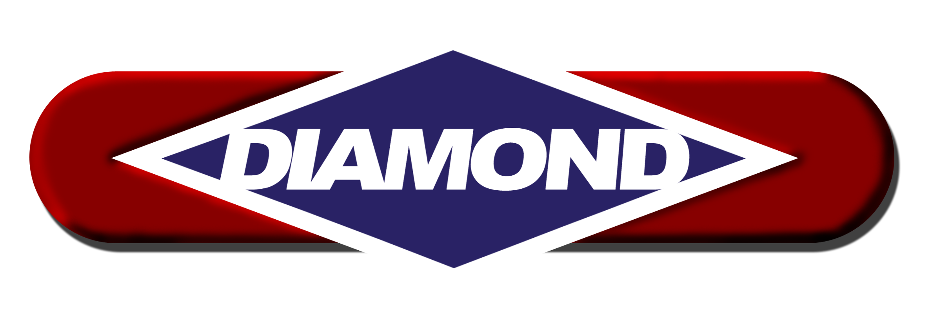
MECKLENBURG COUNTY JAIL CENTRAL - NCMC

DIAMOND PHARMACY SERVICES
645 KOLTER DRIVE
INDIANA, PA 15701-3570

PHONE: 800.882.6337 or
724.349.1111

FAX: 800.523.0008

BUSINESS HOURS: Open 24 hours a day
Monday to Friday 9:00 - 5:00 ET
Saturday 9:00 - 4:30 ET

AFTER HOURS NUMBERS:
800.882.6337 or
724.349.1111

STAT ORDER FAX NUMBER: 866.307.9748
ORDER CUTOFF TIME:
Reorders:
Monday – Saturday 5:00 PM ET the previous day

New Orders:
Monday – Friday 3:30 PM ET
Saturday 12:00 PM ET

Orders needed after cutoff can be phoned in until ~5:00 PM ET

CONTACT PERSONNEL:

Clinical Consultant Pharmacist/Account Executive
Fred Eaton, Pharm.D. Ext: 1043
Email: featon@diamondpharmacy.com

Computer Technician
Jean Marshall Ext: 2496
Email: jmarshall@diamondpharmacy.com

Billing Representative
Karen Hoyt Ext: 14
Email: khoyt@diamondpharmacy.com

Shipping Department
Dan Mock or Dave Lockard Ext: 2608
Email: shippingdept@diamondpharmacy.com

Correctional MAR Department Ext: 1652
Email: PrisonMAR@diamondpharmacy.com

Medication Cart Department
Chuck Allison Ext: 2606
Email: callison@diamondpharmacy.com
Dan Smith Ext: 2627
Email: dsmith@diamondpharmacy.com

Director of Customer Service
Christine Long Ext: 2128
Email: cllong@diamondpharmacy.com

Contract/Startup Questions
Courtney Adams Ext: 1036
Email: cadams@diamondpharmacy.com

Order Forms
Jamie Kitzinger Ext: 2179
Lisa Vallery Ext: 1005
Rachael Houllion Ext: 2258
Courtney Adams Ext. 1036
E-mail: forms@diamondpharmacy.com

Licenses
Sharon Getty Ext: 1031
E-mail: ExecutiveAdmin@diamondpharmacy.com

Facility Information Updates
Dawn Sell Ext: 1081
E-mail: FacilityInformation@diamondpharmacy.com
Carol Duman Ext: 1516
E-mail: FacilityInformation@diamondpharmacy.com

DIAMOND MEDICAL SUPPLY
639 KOLTER DRIVE
INDIANA, PA 15701-2543

PHONE: 888.520.2500 or
724.349.2830

FAX: 888.551.2500 or
724.349.1157

BUSINESS HOURS:
Monday to Friday 9:00 - 5:00 ET
Saturday 9:00 – 3:00 ET

AFTER HOURS NUMBERS:
888.520.2500 or
724.349.2830

CONTACT PERSONNEL:

Customer Service (To Place Orders/Order fulfillment)
Stacie Bynum Ext: 7311
Email: sbynum@diamondpharmacy.com

Technician/Billing Representative
Stacie Bynum Ext: 7311
Email: sbynum@diamondpharmacy.com

Order Online 24/7

NOTES:

